Assignment - 1
Link to code - https://github.com/shivam8496/AccuNox-assesment

Q1- API Data Retrieval and Storage: You are tasked with fetching data from an external REST API, storing it in a local SQLite database, and displaying the retrieved data. The API provides a list of books in JSON format with attributes like title, author, and publication year.

Ans - I wrote the code for this problem assuming that , Multiple books can have same Author and also one Book cloud also have multiple authors, Hence making a Many-to-Many (m*n) cardinality relationship. And for this , managed 3 tables -
1-Books(id,name,publication_year) primaryKey(id)
2-Author(id,name) primaryKey(id)
3-book_author(book_id,author_id)
- foreignKeys(book_id,author_id)
This code could also be done Using ORMs(Object relation Mapping) like sqlAlchemy , but since it is a simple implementation problem I used vanilla sql commands

Q2- Data Processing and Visualization: Given a dataset containing information about students' test scores, fetch the data from an API, calculate the average score, and create a bar chart to visualize the data.

Ans - Here I assumed the that the data of each of the student is coming subject wise , so that I can create various variations of plotting graphs,
In Total I created 4 Graphs -
1-Grouped BarGraph
2-Stacked BarGraph
3-Simple Line Graph
4-HeatMap Graph

Graphs Eg -
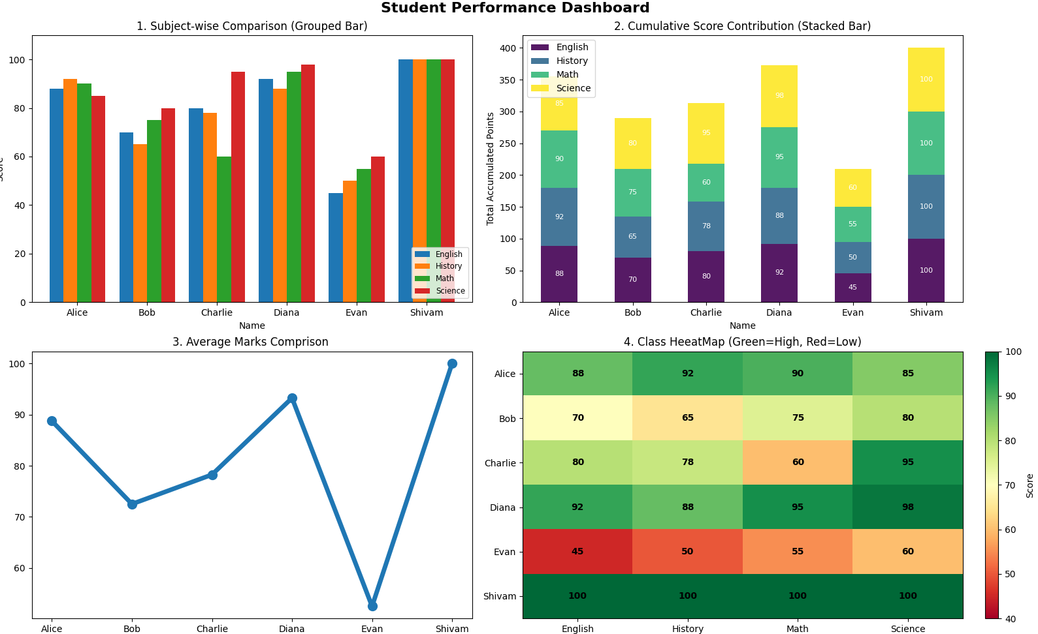

Q3- CSV Data Import to a Database: Write a Python script that reads data from a CSV file containing user information (e.g., name, email) and inserts it into a SQLite database
Ans - Here also I Relational database , I assumed the CSV data from
Will come the given from -
RowID,name,email,role,department,street,pincode
0,User_0,user_0@company.com,Dev,Sales,s1,18774
1,User_1,user_1@company.com,Dev,Sales,s2,767686

So I stored this data in three tables , In order to reduce the Data Redundancy ,
- Employee
- Departments
- Address

But , sometimes CSV could be larger in size containing larger datasets(100k-1M). Loading and saving all Data at once could Crash device, So I used CSV streaming technique to load data in chunks, Avoiding the system OverHead
Q4- Send a link to the most complex Python code you have written
- Link - https://github.com/shivam8496/RAG-Pipeline
- You could find the code explanation in the README.md file

Q5- Send a link to the most complex database code you have written
- Link - https://github.com/shivam8496/Milvus-Database
- Code Explanation in README.md file

Assignment - 2

Q1- Where would you rate yourself on (LLM, Deep Learning, AI, ML). A, B, C [A = can code independently; B = can code under supervision; C = have little or no understanding]
Ans - LLM - [A - Can Code independently]
Deep Learning - [A - Can Code independently]
AI - [A - Can Code independently]
ML- [A - Can Code independently]

Q2- What are the key architectural components to create a chatbot based on LLM? Please explain the approach on a high-level
Ans - 3
1-User Interface
- This is the part where we take the actual user input. There are many ways we could expose the input endpoint of a chatbot like, WebApplication, Mobile app, Chatting applications integration like WhatsApp and Slack extension . But for now I would take Web application as an example
- So the main purpose of this layer would be taking input from the user , Handling message Streaming , Calling APIs and displaying the output .
2-Backend
- This is the part where API calls are sent. This will be the Central controller , It manages and orchestrates all the interaction between UI , the LLM call and external Data Sources and other auxiliary services.
- Tasks it would do is :
  - Authentication and Authorizations
  - Handling Multiple users asynchronously
  - Users wise session and conversation state management
  - Prompting and context injection
  - Calling external LLM APIs
  - Logging , error Handling and Monitoring

There are multiple services that run in Backend
1- Prompt Engineering
- A LLMs output would be as good as a prompt would be .
- We can add predefined System prompts to LLMs so that they reply in specific tone , with defined constraints by following specific persona
- Also we can make dynamic prompts with the users input to enhance the LLMs output.
- We can add COT(Chain of thought ) Technique to design the prompt.

2- Calling LLMs
- We could use LLM APIs like OpenAI APIs , Gemini APIs. Since these are the best LLM Models present in market

3- Retrieval-Augemented Generation (RAG)
- This is the most important architectural component for building a domain-specific chatbot
- Since a LLMs does not have information for our specific data, we need to specifically inject our own data with the prompt to keep LLMs to hallucinate and give required output
- In this approach:
- User input is converted into vector embeddings (using tools like SentenceTransformers )
- Relevant document or chunk are retrieved from the vector databases like Pinecone , Milvus etc
- (Optional) Since vector Databases are not enough because they find similar words but fails to find the connected components .So we could use Knowledge Graph database like Neo4j to make LLM understand the relationship between components
4- Adding of MCP(Model Context Protocol) tools
- LLMs are not only limited to conversation alone
- We can Utilize the MCP services to make LLMs do the different tasks like :
- Database queries
- Scheduling or booking operations etc
5- Management of state and memory
- To maintain multi-turn conversations , memory management is essential
- We can add:
- Short-term memory for recent conversation turns
- Long-term memory: persistent user preference or history
6- Monitoring , logging and FeedBack Loop
- A AI Chatbot should always improve, in order to do that we need to continuously monitor our system , to find the bottlenecks and error (Logging is essential here) , So that we can improve it later

High-Level System Flow
The overall workflow of an LLM-based chatbot can be summarized as follows:
- User submits a query via the UI
- Backend receives and validates the request
- Context and prompt are constructed
- Relevant data is retrieved if required
- LLM generates a response
- Output is post-processed and returned to the user
- Logs and feedback are stored for analysis

Q3- Please explain vector databases. If you were to choose a vector database for a hypothetical problem (you may define the problem) which one will you choose, and why?
Ans -
Vector Database- A vector database is a type of database which stores the data with the semantic meaning of it , These semantic meanings are called Embeddings . In Traditional databases we query the database and based on the exact match we get results. These databases fail whenever we want to search not the exact , but some similarity based pointers . Here comes the Vector Databases , we can query these databases by passing the Vector embedding . And define the similarity thresholds and based on that we could get our results . These Vector embedding are generally generated using Embedding generated Models like (e.g. text-embedding-3-large , Cohere's Embed v4) . There is a dedicated python framework called SentenceTransformer for embedding generations . We can simply give raw user input and the model will generate embeddings accordingly.

Problem Statement -
I am assigned to make a RAG System , for a law firm which has more than 500M internal legal Documents . To help lawyers with legal queries.

Things To keep in mind -
1-Since It is a law firm , all the data is confidential (cannot use any cloud based Database)
2-Hybrid search , Layers need to search by semantic query and strict filters as well
3-Scale and efficiency, Since Database is very large we need faster query responses.

Solution -
I will use Milvus Database for this scenario , and these are the reasons
1- Unlike PineCone(which is Saas) , Milvus is Open source and we can deploy it by ourselves , and literally create our own infrastructure (Since it is Kubernetes based) . Making our database completely private

2-Milvus is Specially designed to handle large datasets, Also there is separated logic for Storage and Computing . Meaning I can scale Searching nodes independently of the storing nodes . And for our 500M datasets , this distributed architecture could get the results in MilliSeconds

3-Not only semantic search we can also do the precise filtering of metadata like in Normal SQL databases

4- It could be expensive for small scenarios , but at such a big scale in our scenario instead I would save us money, because managed services like Pinecone (Which charges vector stored/hour ) , could become so expensive at scale. And with milvus I could pay for only infrastructure that i provision

